## 

By Dark Root (Joy Shideler, Brenton Figures-Mormon)

**Platform: PC ● Target Audience: Teens and up ● ESRB Rating: T ● Number of Players: 1**

*COMING SPRING OF 2024…*

## GAME OUTLINE

*Survive the horrors of Bunnyville!*

A terrible curse has swept over Bunnyville, causing their citizens to mutate into roving, carrot-hungry beasts. You, the Vagabond bunny, must go on a quest to defeat these abominations and put a stop to the source!

Starting off with a tree branch and slingshot, the player must first make their way through the fields surrounding Bunnyville as they fight monsters and talk to various characters. Soon however, they will roam the twisted forest paths and the desert plains as they seek the source of the curse. Finally, the player will venture beneath Bunnyville, into the ancient ruins of the previous kingdom… what dark secrets will they find there?

## GAMEPLAY

Carrot Quest is a top-down 2D adventure-shooter, where players need to slay enemies while exploring the cursed village that is Bunnyville. The enemies are fierce and out for blood…. and carrots. Dodge deadly enemy attacks while utilizing both gun and sword for mixed ranged/melee combat. Create burrows to quickly traverse the battlefield and get the drop on enemies!

Explore the corrupted biomes around Bunnyville, the curse has spread all throughout the land. While searching for clues to solve the Carrot curse, dangerous bosses protect the secrets to reverse the curse. Boss fights of epic proportions that rely on you not only to be quick, but crafty as well.

## GAMEPLAY MECHANICS

Players aren’t defenseless while roaming Carrot Quest’s cursed wilderness – they have both ranged and melee weapons to help them defeat their foes. Players will take down enemies from afar with their gun and cut them down with their sword.

Using the dodge and burrow mechanic, the Player can avoid enemies and obstacles in their way. Dodging will let the Player avoid enemy attacks, while burrowing will let them pass obstacles and quickly move back and forth through the created burrows.

Players will explore the world, taking down enemies while searching for the source of the Carrot Curse. NPCs will give side quests and drop clues helping players solve the mystery, and the Player can build relationships with them. Players will obtain upgrades and new abilities as they explore and gain access to new parts of Bunnyville.

Throughout the world there will be carrot seeds that players can find and trade with villagers at shops for materials and other items. Enemies also drop a predetermined amount of carrot seeds based on enemy type.

## CHARACTERS

Players will meet a variety of characters as they venture through cursed Bunnyville, each with interests and secrets of their own.

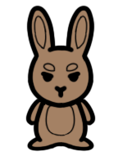

**The Vagabond** - our silent protagonist who is searching for the source of the curse affecting Bunnyville. While adorable at first glance, the Vagabond will do anything and everything to achieve their goal.

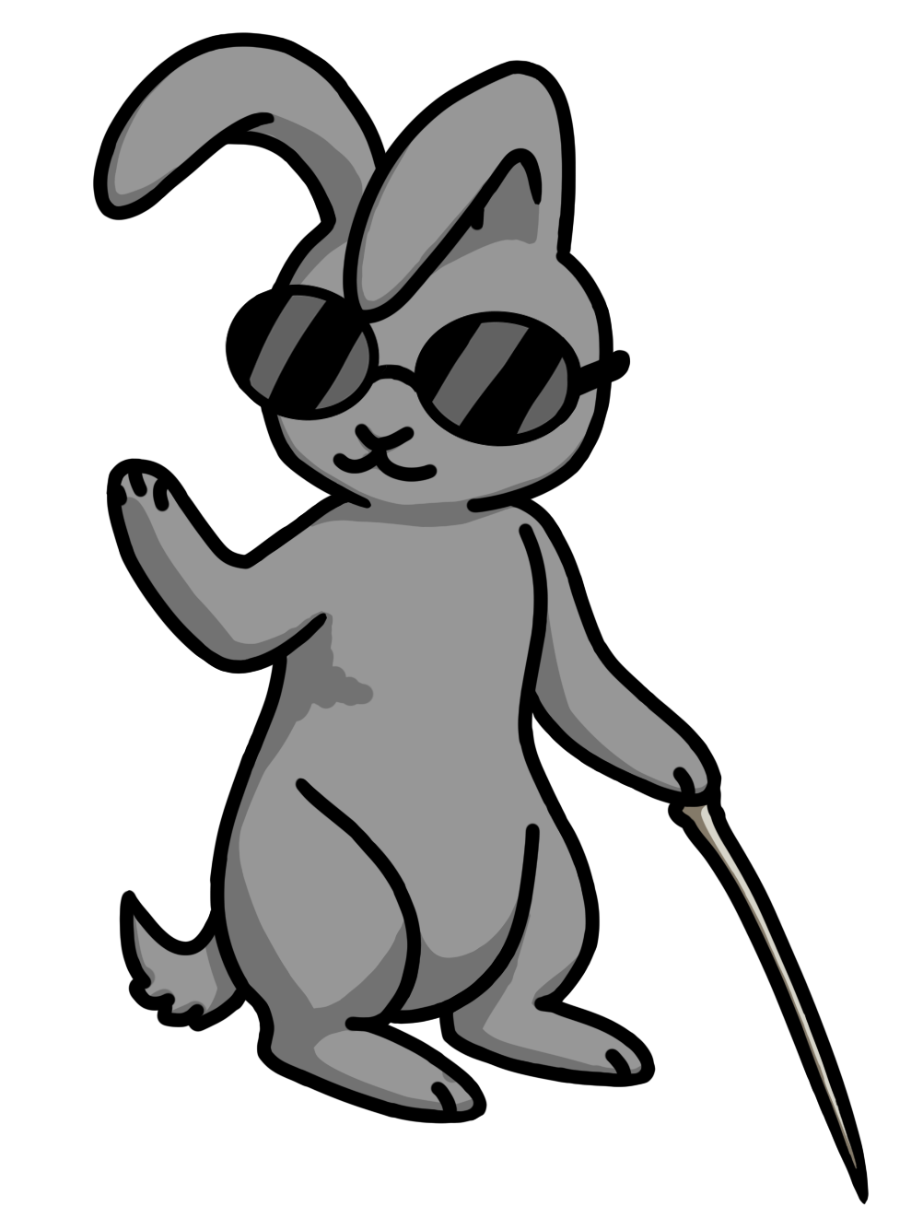

**Hyacinth** - the village wise bunny or the village Sarcastic bunny as everyone says. A loose mentor figure to the Vagabond, but by no means are the two closely attached. Hyacinth is a fiercely independent bunny, preferring to do most things himself**.**

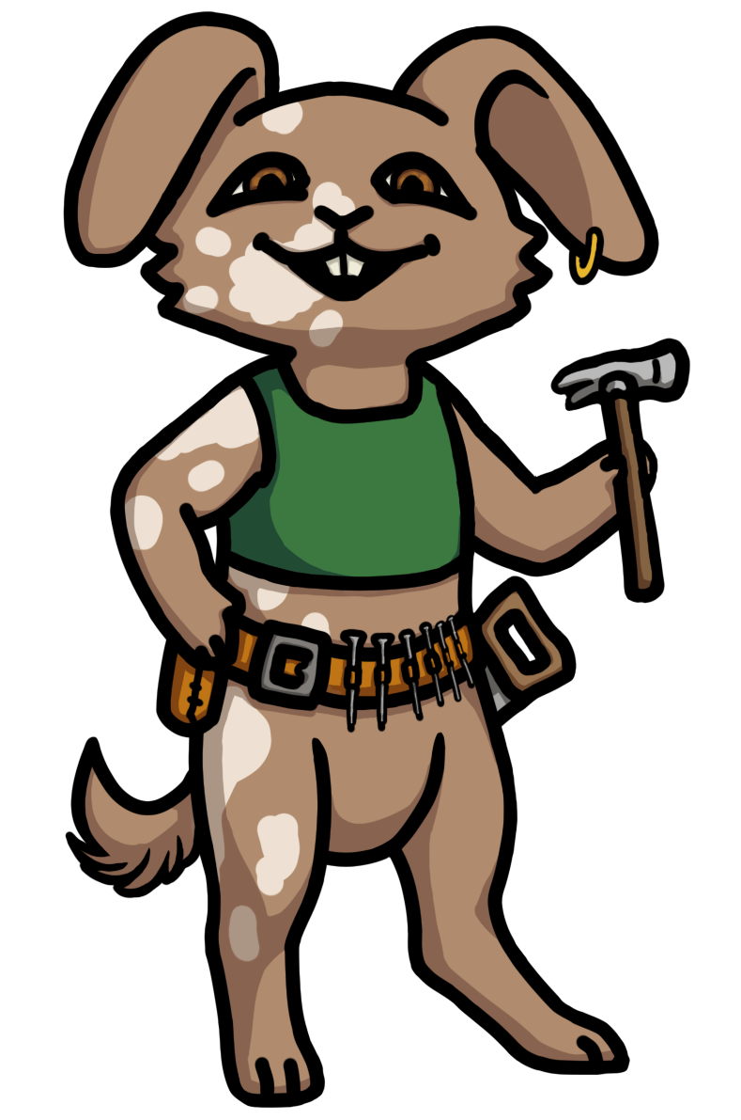**Oakly** - the main builder of the town. He can build anything and everything with the right materials, which is where The Vagabond comes in. Bring back materials to Oakly and he will help progress the storyline of the game.

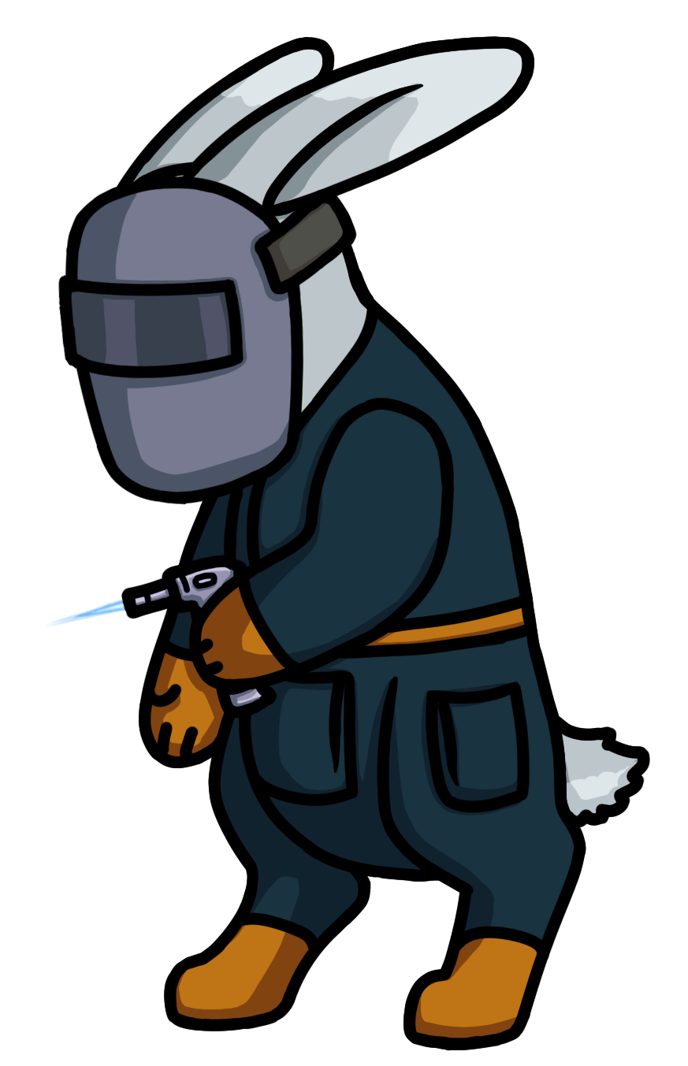**Dewdrop** – a wonderful engineer bunny that assists the Vagabond in upgrading some of their equipment. Preferring the comfort of his workshop, he says little, but does a lot. An essential denizen of Bunnyville.

## A tree with a hole in the trunk Description automatically generatedGAME WORLD

The Vagabond must search all throughout Bunnyville and the surrounding areas to find the cause of the terrible curse. Players will explore grasslands, deserts, and even cursed forests as they make their way to solving the mystery.

Carrot Quest, while initially having a very cheery, bright tone changes all too quickly when the curse affects the game world. Disfigured rabbits, mutated wildlife, and all other sorts of eldritch horror will obstruct your path as The Vagabond searches for the cure behind the curse.

Mood

Bunnyville is a village that lives in constant denial. The land is mutated, dozens of townspeople turned crazed monsters, and the worst part is, nobody seems to know how to stop the curse causing it all! It’s up to you to piece together the pieces of how the tragedy started and how to put an end to it once and for all.

## GAME EXPERIENCE

*Be the hero Bunnyville needs…*

After years of slow descent into corruption, the citizens of Bunnyville are on their last rope. Soon, there will be nothing left of the happy village Bunnyville used to be. Can you save them from the mutation and madness before it’s too late?

While Carrot Quest may seem cute and cheery at first, the dark corruption of the Carrot Curse doesn’t hide itself for long. The music of the game reflects this descent, and slowly becomes more discordant and unsettling.

The music of Carrot Quest shows the off-putting nature of Bunnyville. Things definitely don’t seem right at first, but they don’t just outright fall apart either. You have to slowly peel back the ever-haunting layers of mutated rabbits, carnivorous wildlife, and denial riddled villagers to ever have a chance of making it out alive.

## ENEMIES

The enemies will be a wide variety of cursed wildlife, ranging from slimes, to mutated sunflowers, all the way to demon rabbits. The enemies get bigger and badder the closer you are to the source of the curse! Enemies become more aggressive the closer you are to finding the curse, so be wary!

Even common enemies are very dangerous to the player. Observe them carefully as you traverse the cursed wasteland.

There will be a plethora of bosses that players will encounter as they solve the mystery behind the curse of Bunnyville.

## MULTIPLAYER / BONUS MATERIALS

Carrot Quest is a game all about exploring the cursed wilderness of Bunnyville. The game best works as a single player experience, where players can focus on the story behind the mythical Carrot curse.

## Bonus content such as DLC expansions will be sold after the game’s release, to expand on the story of Carrot Quest and provide new gameplay experiences.



## MONETIZATION

Carrot Quest will be available as a one-time purchase of 9.99$ on Steam and Epic.

We believe this price point will allow us to have a sizeable audience, as a relatively cheap price for a full adventure experience, with replayability.